We’re looking forward to rocking out with you at Volbeat’s VIP Experience!

Please take a moment to read the information below to make sure you’re all set for an unforgettable night.

EVENT DETAILS
Package Name: “G.O.A.T.” Private Meet & Greet Experience
Date: Saturday, November 8th 2025
City: Manchester, UK
Venue: AO Arena
Victoria Station Approach, Hunts Bank, Cheetham Hill, Manchester M3 1AR, United Kingdom
Saturday
8 November
15:15 | VIP CHECK-IN OPENS / EARLY SHOPPING OPENS
15:30 | MUST BE CHECKED IN TO PARTICIPATE IN PRODUCTION TOUR AND MEET & GREET + PHOTO
18:45 | SUPPORTING BAND #1 APPROXIMATE START TIME
19:35 | SUPPORTING BAND #2 APPROXIMATE START TIME
20:55 | VOLBEAT APPROXIMATE SHOW START TIME
21:00 | VIP CHECK-IN CLOSES
*You must be checked in by 15:30 to participate in the Meet & Greet. Late arrivals may forfeit package benefits.*
All times are approximate and subject to change. We will notify you by email if there are any significant updates to the schedule above.

Per venue policy, seat access begins at 18:00 (general doors). You’re welcome to wait in the G.O.A.T Exclusive Area till access to your seats is available.

CHECK-IN DETAILS
Location: Event Floor Entrance in Trinity Tunnel

VIP Check-In Opens: 15:15

Please see the map attached at the end of this email, or click HERE and select the VIP Check-In icon for directions. Look out for VIP signage pictured below!
Photo ID will be required at the Check-In desk to verify you as the package holder. Please ensure you have this with you.

PRODUCTION TOUR
Because the tour includes walking around the venue and up stairs, we want to ensure we are prepared to meet the diverse needs of our guests. If you require any assistance when walking long distances or up stairs, please contact us HERE so we can help accommodate your needs.

MEET & GREET PHOTOS
Now for the fun part! Our photographer will be capturing one (1) individual professional photo with the band.
For guests selecting a general admission ticket, we always strive to provide early entry to the floor. However, due to the Meet & Greet production schedule, early floor access cannot be guaranteed.
You MUST be Checked-in by 15:30 to participate in the Meet & Greet.
Personal phones, cameras, and any venue-prohibited items will not be allowed into the Meet & Greet area. Please check your venue's policy for more information on prohibited items. There will be no autographs at the Meet & Greet.
CLICK HERE TO VIEW YOUR PHOTOS 5-7 DAYS AFTER THE EVENT

G.O.A.T. EXCLUSIVE AREA
Enjoy access to an intimate area for 'G.O.A.T.' Private Meet & Greet Experience package holders. This space is a spot to relax while you wait for your M&G with the band. Light snacks and beverages are available.

VENUE INFORMATION
We want to make sure your entry goes smoothly; please click HERE for more venue details and general information.

FREQUENTLY ASKED QUESTIONS
I purchased these tickets as a gift for someone else and am not attending.
If someone other than the original ticket purchaser attends the concert, while they may still be allowed entry, they might encounter issues at the VIP Check-In, including possible delays or rejection.
To avoid these issues when tickets have been purchased on behalf of someone else, we suggest following the steps below:
- Ensure the recipients of the tickets are logged into the ticket agent's account (e.g. Ticketmaster) and can access the tickets via the app using your login details. Please note that screenshots of tickets might not be accepted.
- Make sure your guests have a copy of your photo ID, which will be required at Check-In.
- Give your guests a copy of this email to bring to the show to verify that we are aware of their attendance on your behalf.
- The original ticket purchaser is exclusively responsible for forwarding all relevant information related to attending the show to the new ticket holder. This includes all details regarding timings and locations. SUPER will not forward any information to recipients of transferred tickets.
Where do I collect my VIP merchandise?
Your VIP-exclusive merchandise item will be distributed at VIP Check-In. Merchandise must be collected at this event and cannot be shipped out after.
Where do I collect my autographed merchandise?
You will receive your autographed and other VIP merchandise at VIP Check-In.
What if I arrive after the designated time?
If you arrive after the Check-In deadline, we cannot guarantee that you will receive all your package benefits.

CONTACT US
If you need assistance on the day of the show, text us on WhatsApp at +447822034931.
Please note this number is for the day of show only and is a WhatsApp ONLY text message assistance service (cannot accept phone calls).
If your question has not been answered above, please contact us via our Customer Support form HERE.
We look forward to seeing you!

PLEASE SEE BELOW FOR A LOOK AT
YOUR CHECK-IN LOCATION & VIP SIGNAGE!

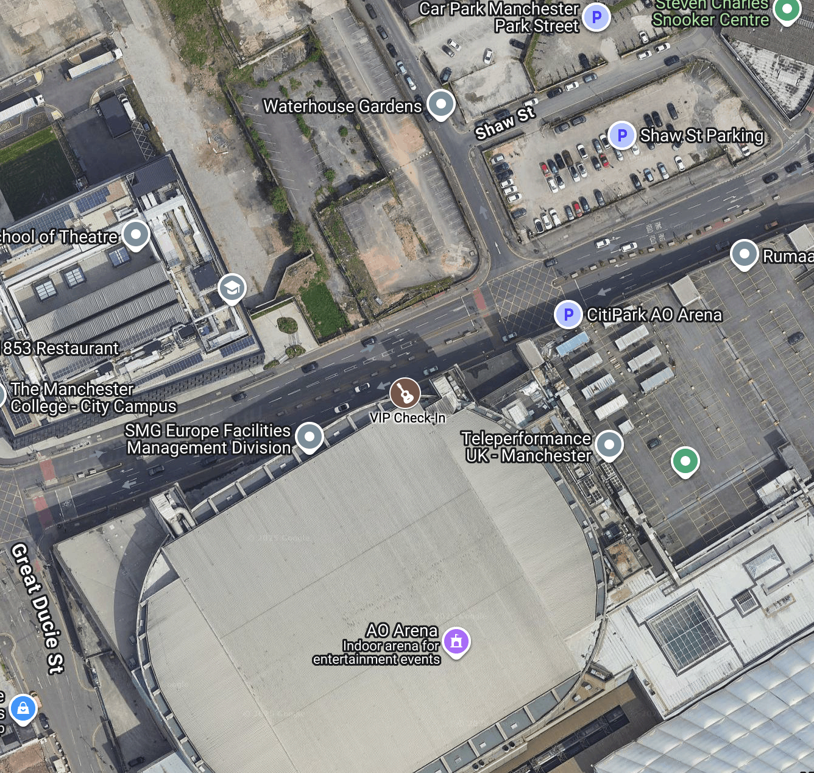
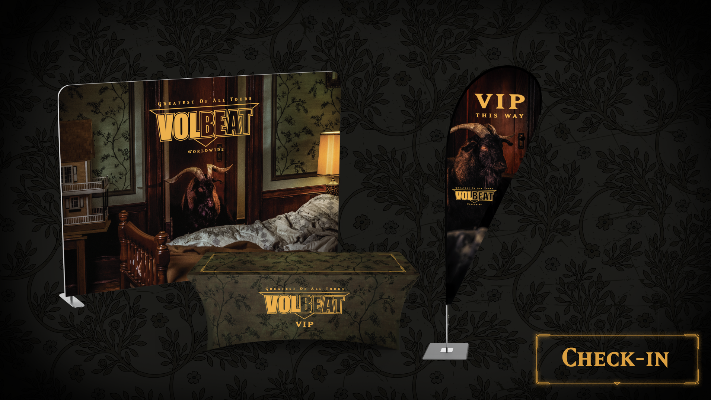

Terms & Conditions
Packages are open to all ages. Guests under 18 must be accompanied by an adult. All package purchasers will be contacted 3-5 days prior to the event date with the event schedule, check-in location, time, and instructions on where to pick up package inclusions. Such information will be sent by the venue box office to the e-mail address or telephone number provided at the time of purchase. If you have not received this 3 days before the show, please contact us immediately here. Merchandise items included in your package will be available for pickup at the venue the day of the show at the designated VIP check-in location. All merchandise must be collected onsite on the day of the show and will not be mailed if you do not check-in. You must bring a valid photo ID matching the purchaser’s name on this order to the event. Guests who cannot present a photo ID matching the purchaser’s name on the order will be turned away. By purchasing a package, you consent to have your photograph taken at the event. These images may appear in a collective album that will be visible by other event attendees. Certain images may be shared by SUPER, the photographer, and/or the artist for promotional purposes. Events, dates, venue location, inclusions, merchandise, package programs, and amenities may vary market-by-market and are subject to change and cancellation at any time. All sales are final. No refunds, exchanges, resales, or transfers will be permitted. All package elements will be rendered invalid if resold or transferred. Please note this offer is not valid if this ticket was purchased via Fan to Fan Resale. Partial attendance at a single-day event or multiple-day event is not eligible for a refund. The artist, tour promoter, ticketing company, venue and any other affiliated parties reserve the right to sell additional items not currently listed, including but not limited to single-day tickets or additional packages, at their sole discretion. The artist, tour, promoter, ticketing company, venue or any other affiliated parties are not responsible for outdated or inaccurate information provided by the guest at the time of purchase which may result in undelivered product.

